COSC 3380
Name: __________________ PS ID #_______

Project 1:
(100 points)
(Due date found in the COSC 3380 BB Calendar!)

1. a 0 points
1. b 40 points
1. c 10 points

PLEASE ENTER YOUR GRADE IN THIS BOX & ALSO on the CHECK SHEET:

1. (50 points)

Please refer to Project 1 with Line Numbers for ERD Modeling.doc for the Requirements.

a. (0 points – separate document) Copy and Paste the ERD Model (must fit on one page) from Project 1 with Line Numbers for ERD Modeling.doc
(Conceptual Model – What - Analysis).

Please remember the ERD Diagram does not have any OVALS on it.)

(Just place the ERD Model HERE, then delete everything with yellow or blue background before submitting).

b. (40 points) COSC3380 Relational Model (must fit on one page)
(Internal Model – How - Design).
#Relations/Tables: ___
Please indicate the number of Relations above.

Copy and Paste the ERD Model (must fit on one page) from Project 1 with Line Numbers for ERD Modeling.doc
Use the Labeled Ovals to show the relations/tables (each E becomes a relation, each R becomes a relation, group E on many side and the R into one relation)

This is just an example of ERD to Relational mapping:

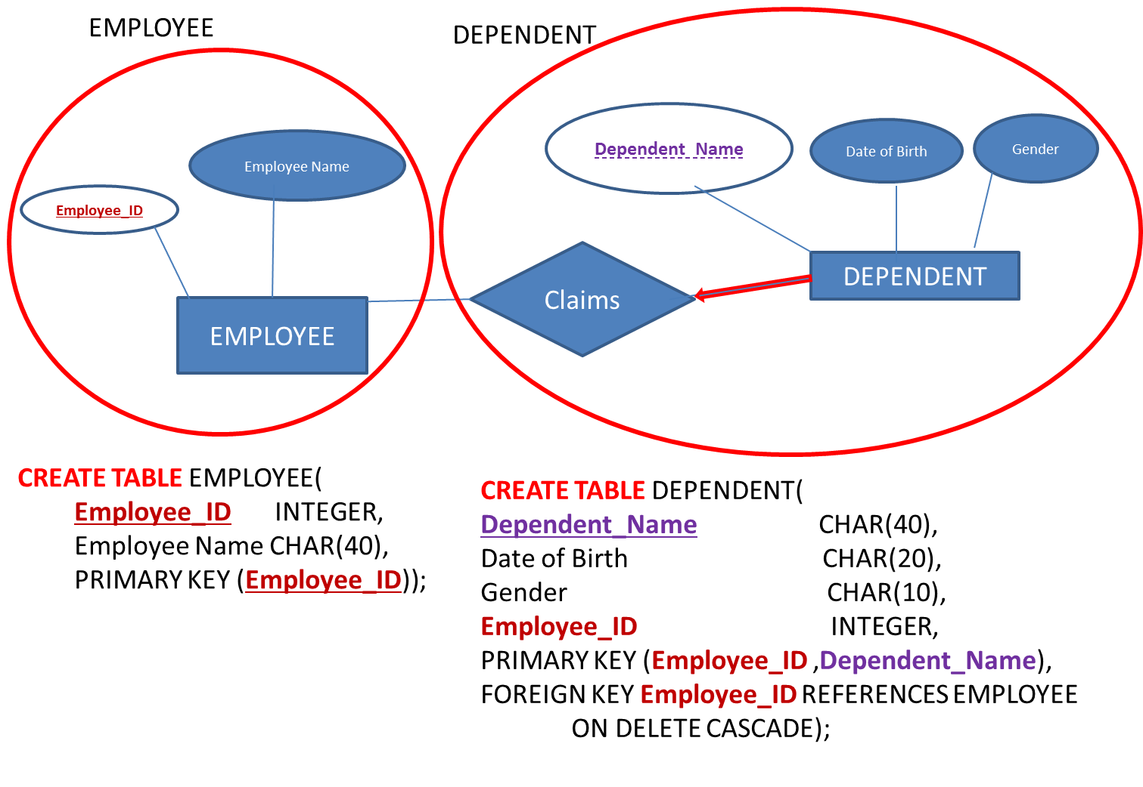

SOLUTION:

c. (10 points) COSC3380 Relational Model
(Internal Model – How - Design).
#Views/Tables: ___

Please indicate the number of Views above.

Define each View in the table format… CREATE VIEW….

